Week 0 Unit 1

Getting started

Please perform the following steps to be prepared for this course.

Table of Contents

1 Create an SAP HANA Cloud Platform (HCP) Developer Account 2

2 Get Familiar with the Development Environment 4

3 Connect to the Demo System ES4 7

4 (Optional) Create a New Destination to a Public OData Provider 12

## Preview

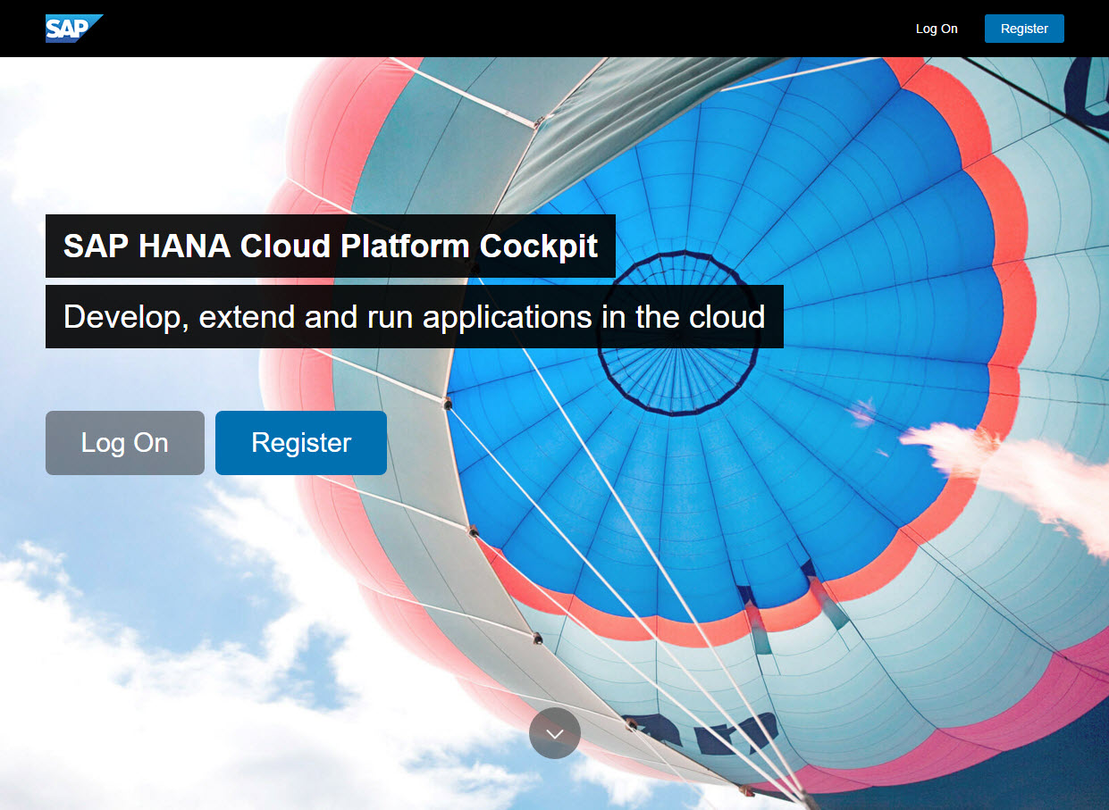

Figure 1 - The SAP Hana Cloud Platform start page

# **Create aN SAP HANA Cloud Platform (HCP) Developer Account**

In this step, you will create your developer account that can be used for the exercises in this course.

### Register a new account

| Explanation | **Screenshot** |
| --- | --- |
| 1. Open Google Chrome. Navigate to the following URL:   <https://account.hanatrial.ondemand.com/>  **Note: Installing Google Chrome** We recommend you use Google Chrome for this course. If you don’t have it installed yet, go to the following URL and follow the steps described there: [**https://www.google.de/chrome/browser/desktop/**](https://www.google.de/chrome/browser/desktop/) |  |
| 1. Click “Register” to create a free SAP HANA developer account |  |
| 1. Enter your name and e-mail address and choose a password. 2. Accept the terms & conditions and click “Register”.   **Note: Trial Account** A developer account on SAP HANA Cloud Platform is provided to you with a free and perpetual [developer license](https://accounts.sap.com/ui/public/viewTextResource?scenario=SAP_HANA_Cloud_Developer_Edition&resourceType=RESOURCE_TERMS_OF_USE&locale=en_US&spDisplayName=SAP%20HANA%20Cloud%20Developer%20Edition) that you accept when you create your account. You can use such an account to test out the platform or run demo scenarios. |  |
| 1. A confirmation e-mail has been sent to your account. Open it and choose “Click here to activate your account”. |  |
| 1. You should see a confirmation dialog. Click “Continue” to go to the SAP HANA Cloud Platform Cockpit. |  |
| 1. Close the “News and Announcements” popup and have a look at the SAP HANA Cloud Platform Cockpit. This is your entry point for managing cloud apps and configurations. |  |

# Get Familiar with the Development Environment

In this step, you will open SAP Web IDE and create a simple test page.

### Open SAP Web IDE

| Explanation | **Screenshot** |
| --- | --- |
| 1. In HCP, you can consume tools and applications as services.   Click “Services” to see a list of applications that have been added automatically to your account. |  |
| 1. You can now see all applications that are connected to your account. In the search field, filter for “web” and click the “SAP Web IDE“ tile. |  |
| 1. Click the link “Open SAP Web IDE” to open an instance connected to your account. |  |
| 1. Have a look at the start page of SAP Web IDE. It contains useful links and shortcuts to the most important actions. |  |
| 1. (Optional) Add a bookmark to SAP Web IDE by pressing “CTRL+D” in Google Chrome. You will need this link to your development environment frequently throughout the course. |  |

### webapp/index.html (NEW)

**<!DOCTYPE html >**

**<html>**

**<head>**

**<meta http-equiv="X-UA-Compatible" content="IE=edge"/>**

**<meta charset="UTF-8">**

**<title>OpenSAP - Developing Web Apps with SAPUI5</title>**

**</head>**

**<body>**

**<p>Hello World</p>**

**</body>**

**</html>**

Go to the development perspective by clicking the “</>”icon in the left toolbar. On the left side you will see a folder list with just one entry: “Workspace”. Add a new project folder MyApp by right-clicking it and selecting “New > Folder”.

Inside the project folder, create a new folder webapp which will contain all sources of the app we will create throughout the first weeks of this course. Now create a new root HTML file called index.html in your app folder with the contents of the listing above.

Your workspace should now look like this:

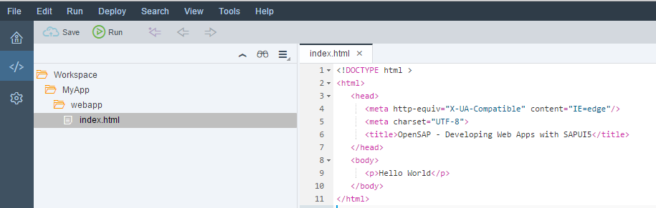

Figure 1 - Workspace for the test page

Save your changes and click the  button in the header toolbar. A new tab will open with the preview of your app. Your “app” (remember this is just a test) is now simulated in the cloud and you will see the “Hello World” text on the screen:

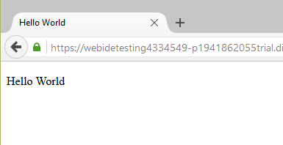

Figure 2 - Preview of the test page

That’s it for today’s coding. Feel free to play around a little bit with SAP Web IDE to get familiar with the tool so you are ready for the course exercises that start next week.

# **Connect to the Demo System ES4**

In this step, we configure the back-end system connection to access real service data in our projects.

### Sign up and get started with the SAP Gateway Demo Consumption System

| Explanation | **Screenshot** |
| --- | --- |
| 1. Navigate to the following URL:   <http://scn.sap.com/docs/DOC-40986>   1. Click “Sign up here!” to connect your SAP HCP developer account to the demo system. |  |
| 1. Accept the disclaimer for using the demo system by clicking “Accept”. |  |
| 1. Your user information should automatically be connected to your SAP HCP account that you have created in the previous step. Click “Register” to continue. |  |
| 1. A confirmation e-mail has been sent to your account again. Open it and press the “SAP Gateway WebGUI” link. |  |
| 1. Log on to the gateway system with the login data from the e-mail. |  |
| 1. Change the initial password by entering the old and a new password. 2. **Write down the new password for the next configuration step.** |  |
| 1. After changing the password you will see the main screen of the web logon. Close the window and return to the SAP HCP Cockpit |  |
| 1. You can optionally have a look at the service interface by opening the following URL:   <https://sapes4.sapdevcenter.com/sap/opu/odata/IWBEP/GWSAMPLE_BASIC/?sap-ds-debug=true> |  |

### Create a destination ES4 in the SAP HCP cockpit

| Explanation | **Screenshot** |
| --- | --- |
| 1. Go to the Destinations page of the SAP HCP Cockpit by opening the following URL and pressing the menu item “Destinations”:   <https://account.hanatrial.ondemand.com/cockpit> |  |
| 1. Choose “New Destination” to open a configuration panel. |  |
| 1. In the **Destination Configuration** section below, make the following entries.   **Note:**  Optionally, you can set your user name and user password. If you don’t fill out User and Password from the previous step, you will be asked for your ES4 Gateway system credentials every time you start your app and request back-end data. | |  |  | | --- | --- | | Field | Entry | | Name | ES4 | | Type | HTTP | | Description | ES4 Demo Service | | URL | https://sapes4.sapdevcenter.com | | Proxy Type | Internet | | Authentication | BasicAuthentication | | User | <your user, e.g. p1234567890> | | Password | <your password for the ES4 system> | |
| 1. The complete **Destination Configuration** form should look like this. 2. Choose **Save**. | C:\Users\D050079\AppData\Local\Temp\SNAGHTMLf8c8250.PNG |
| 1. Click the “check” icon on the right side of the newly created destination and make sure that the connection test is successful. |  |

That’s it, you are now ready to start with the course. Have fun!

# **(Optional) Create a New Destination to a Public OData Provider**

The Northwind Traders sample database contains the sales data for a fictitious company called Northwind Traders, which imports and exports specialty foods from around the world. It is available as a set of public services at <http://www.odata.org>. The Northwind public OData service, like many other OData services, can be used as the data source when creating SAPUI5 applications.

**Note:**This service will not be used throughout the exercises in this course. Nevertheless, it might be an interesting data source for your further app developments.

| Explanation | **Screenshot** |
| --- | --- |
| 1. Access the SAP HANA Cloud Platform Cockpit via this link: <https://account.hanatrial.ondemand.com/cockpit> |  |
| 1. On the left bar menu, click **Destination** and then choose **New Destination**. |  |
| 1. In the **Destination Configuration** section below, make the following entries. | |  |  | | --- | --- | | Field | Entry | | Name | northwind | | Type | HTTP | | Description | Northwind OData Service | | URL | http://services.odata.org/ | | Proxy Type | Internet | | Authentication | NoAuthentication | |
| 1. The complete **Destination Configuration** form should look like this. |  |
| 1. Choose **Save**. |  |

**Coding Samples**

Any software coding or code lines/strings (“Code”) provided in this documentation are only examples, and are not intended for use in a productive system environment. The Code is only intended to better explain and visualize the syntax and phrasing rules for certain SAP coding. SAP does not warrant the correctness or completeness of the Code provided herein and SAP shall not be liable for errors or damage cause by use of the Code, except where such damage was caused by SAP with intent or through gross negligence.